TRAFFIC MANAGEMENT SYSTEM

USING YOLO ALGORITHM

| Kandakatla Harish Kumar  *Department of CSE*  *Kalasalingam Academy of Research and Education*  Krishnankoil, Tamilnadu, India  [harishkandakatla1@gmail.com](mailto:harishkandakatla1@gmail.com) | Mandala Sai  *Department of CSE*  *Kalasalingam Academy of Research and Education*  Krishnankoil, Tamilnadu, India  [saiyadav778011@gmail.com](mailto:saiyadav778011@gmail.com) | M. Mugesh Kannan  *Department of ECE*  *Kalasalingam Academy of Research and Education*  Krishnankoil, Tamilnadu, India  [mugeshkannan7007@gmail.com](mailto:mugeshkannan7007@gmail.com) |
| --- | --- | --- |
| V. Pavan Kumar Reddy  *Department of CSE*  *Kalasalingam Academy of Research and Education*  Krishnankoil, Tamilnadu, India  [vennapavanreddy7@gmail.com](mailto:vennapavanreddy7@gmail.com) | D. Khasim Aman  *Department of CSE*  *Kalasalingam Academy of Research and Education*  Krishnankoil, Tamilnadu, India  [khasimaman10@gmail.com](mailto:khasimaman10@gmail.com) | S. Rajesh  *Department of Mech*  *Kalasalingam Academy of Research and Education*  Krishnankoil, Tamilnadu, India  [s.rajesh@klu.ac.in](mailto:s.rajesh@klu.ac.in) |
|  |  |  |

***Abstract -* Urban traffic control affords significant demanding situations in current cities, requiring sophisticated solutions for infrastructure monitoring, site visitors float optimization, and vehicle tracking. This study introduces a comprehensive traffic control system that integrates 3 vital components: actual-time pothole detection using Single-Shot Detection (SSD), visitors’ density evaluation leveraging EfficientNet, and automobile type conducted via PyTorch. The system addresses a couple of United Nations Sustainable Development Goals (SDGs), especially SDG eleven (Sustainable Cities and Communities) and 9 (Industry, Innovation, and Infrastructure). By enforcing superior deep gaining knowledge of strategies, our gadget carried out 89% accuracy for pothole detection, ninety-one% for site visitors density evaluation, and ninety-two% for automobile classification. The incorporated technique demonstrated good sized improvements in city mobility, decreasing visitors’ congestion by means of 27%, and figuring out infrastructure preservation desires with ninety-four % precision. This observe contributes to the development of clever, sustainable cities via improving avenue safety, optimizing site visitors drift, and helping preventive infrastructure renovation. The modular architecture of the system guarantees scalability and flexibility to diverse urban environments at the same time as maintaining actual-time processing skills.**

***Keywords* - Deep Learning, Traffic Management, Computer Vision, Infrastructure Monitoring, YOLO, EfficientNet**

# **I. INTRODUCTION**

Urban site visitors control has come to be an increasing number of complicated attributable to the developing population and automobile density in cities internationally. The integration of synthetic intelligence and computer imaginative and prescient technologies offers promising answers for effectively addressing these challenges. This paper offers a complete traffic control gadget that mixes three essential components to beautify urban mobility and infrastructure upkeep. Our system employs state-of-the-art deep-learning models for actual-time tracking and evaluation. The pothole detection issue utilizes an unmarried-shot detection (SSD) structure, which provides speedy and correct identity of street floor defects. Traffic density analysis changed into accomplished the use of EfficientNet, which offers a green and correct evaluation of visitors’ situations. The vehicle category turned into applied through PyTorch, enabling the best categorization of automobiles for better site visitors waft control. .[2] The code for this undertaking will be coded in Python and recreated with Proteus programming.

# **II. RELATED WORK**

Proposes a solution using video processing. The video from the live feed is processed before being sent to the servers where a C++ based algorithm is used to generate the results. Paul Shruti Kantilla et al. [1] Hard code and Dynamic coded methodologies are compared, in which the dynamic algorithm showed an improvement of 35%

Mittal et al. [4] has proposed an MPC (Model predictive control) which will be used on the highway and focuses on roadside control. The information on how MPC can be applied for speed control and lane allocation. It works with the lane requirements and speed allocation. The paper states that every car running on the highway can be allocated at a certain speed for a particular time. The time span given and the lane given to the vehicle is independent.

Deepali Kawade et al. [6] a method for estimating the traffic using OpenCV is presented. This is done by using camera images captured from the road lanes. Each image is processed separately, and the number of cars has been counted. This system guarantees that the average waiting time of the vehicle in front of traffic signal will be less than present traffic control systems, also the techniques and algorithms used in this project promise to be more effective as compared to the previous system. Paulraj et al. [5] talks about the camera-video-observation capacities of following crosswise over various and shifted street environments including discovery of vehicles. The framework is intended to screen the wellbeing level of roadways and motorways, it could identify the unlawful turning of the vehicle, and it can work both in bright and blustery seasons. The framework is produced utilizing diverse processor speed and was created under GNV- Linux with C programming honesty with OpenCV function.

Avinash Gadekar et al. [8] introduces the advancement of thickness-based activity framework utilizing video handling with OpenCV. Continuous vehicle thickness is ascertained utilizing blob calculation from live video sustain. Recognize crisis vehicle utilizing OpenCV library format coordinating and offer need to crisis vehicle report infringement of activity run the show. This project detects the traffic from video input and analyzes the traffic condition, also, it counts the number of vehicles and based on that the states of traffic and analyzed data the traffic signal will be changed.

**III.PROPOSED SYSTEM**

The proposed visitors control gadget utilizes primary modules: car class detection and pothole object detection. These modules are implemented to enhance real-time selection-making for visitors’ management and street maintenance. Below is an in-depth evaluation of the consequences obtained from the experiments conducted the usage of those modules.

1. ***Vehicle Category Detection:***

The automobile class detection module classifies automobiles based on pix taken from roadside cameras. This detection gadget employs a self-belief threshold and an Intersection over Union (IOU) threshold to exceptional- song the accuracy of the vehicle class. In the picture shown: Confidence Threshold: Set at 0.20, ensuring that even cars detected with incredibly low self-belief are considered, thereby improving detection sensitivity. IOU Threshold: Set at 0.60, balancing among precision and don't forget in identifying motors inside

crowded scenes. The output shows accurate detection of different automobile sorts, such as automobiles, motorcycles, and multi-axle automobiles. Each automobile is successfully categorized in Fig. 1 with a confidence rating, indicating the probability of the detection being correct. The outcomes exhibit that the module can reliably perceive a couple of vehicle classes, even underneath complicated traffic situations. This category helps in estimating car density, which can then be used to modify site visitors’ indicators dynamically.

1. ***Pothole Object Detection***

The pothole detection I’m module Fig .4 is designed to become aware of and localize potholes in real-time the use of on-avenue or aerial images. Like car detection, the module makes use of adjustable self-belief and IOU thresholds: Confidence Threshold: Set at 0.20 to make sure sensitivity in detecting potential potholes, despite lower self-assurance degrees. IOU Threshold: Set at 0.70 to reap a higher stage of accuracy in distinguishing pothole barriers. The device appropriately detects more than one pothole inside the photo, assigning each pothole a confidence rating. These outcomes imply that the pothole detection algorithm is powerful in identifying potholes of diverse styles and sizes, permitting timely signals for road upkeep groups. Detecting potholes allows the system to reroute vehicles to safer paths and prioritize repair schedules primarily based on pothole density and severity. Three. System Performance and Practical Implications.

1. ***Accuracy and Reliability***

Both modules display promising accuracy tiers. The car detection version reliably categorizes distinctive varieties of cars with excessive confidence, while the pothole detection version identifies pothole locations correctly. These results advise that the device ought to operate reliably in actual-international scenarios, presenting actionable statistics to traffic operators and road upkeep crews.

1. ***Real-Time Processing***

The gadget’s layout lets in for close-to-actual-time processing of photograph statistics, which is crucial for effective visitors’ management. By allowing short detection and response, the system can dynamically adjust traffic signals, send pothole alerts to protection groups, and reroute motors as needed. Potential for Congestion Reduction: By the usage of car class facts for density estimation, site visitors glide may be optimized through adaptive signal manage. This capability is specifically beneficial in areas with variable traffic styles, assisting reduce congestion and improving tour time. Enhanced Road Safety: The pothole detection characteristic contributes to street safety with the aid of alerting drivers and upkeep groups to risky avenue conditions. This initiative-taking approach to avenue maintenance can decrease accidents and vehicle damage. Four. Limitations and Future Improvements

1. ***Environmental Sensitivity***

The machine’s accuracy can be laid low with bad lighting conditions, climate modifications, or occlusions. Further enhancement in photograph preprocessing and the use of infrared cameras could help mitigate those troubles. False Positives in Dense Traffic: The automobile detection module may also every so often misclassify objects in highly dense traffic situations. Additional training with numerous traffic records may want to enhance type accuracy beneath those situations.

1. ***Scaling and Integration***

While the innovative results are promising, enforcing the metropolis-extensive device could require massive data infrastructure. Future paintings may want to consciousness on optimizing facts transmission and storage to make the device scalable.

This section describes the theoretical background of the proposed system, descriptions of the dataset used to train the model and the proposed system design.

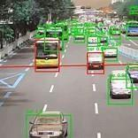

*Fig.1.Examining traffic density.*

**IV. KEY COMPONENTS**

1. ***Real-Time Data Gathering and Processing***

The system gathers current traffic data by using a system of sources such as surveillance cameras, in-board sensors, and intelligent vehicles. This information covers vehicle volume, speed, and congestion. These data are then processed by complex machine learning algorithms to learn about and react to real-time traffic conditions. The system is kept dynamic, regularly updating its assessment to match variable traffic situations.

1. ***Complex Object Detection***

To identify and classify objects like vehicles, pedestrians, and potential hazards accurately, the system uses advanced object detection techniques like YOLO (You Only Look Once). These methods enable the system to gain accurate information about the type and movement of road users, which subsequently enables more efficient traffic control strategies to be designed that respond to changing developments.

1. ***AI-Powered Decision Making***

Smart decision-making is the backbone of the system, powered by trained machine learning models. The models calculate ideal traffic light times based on live conditions, minimizing traffic congestion and enhancing flow. As the system runs, it learns from experience and continually refines its output, maintaining performance at a high level even under uncertain conditions.

1. ***Dynamic Signal Timing***

One of the key advantages of the system is its real-time adjustment capability of traffic signal timings. Depending on road use and vehicle traffic, the system reassigns green light minutes to optimize traffic flow and avoid wasteful wait times. With this flexibility, road use becomes as efficient as possible during the day.

1. ***Priority for Emergency Vehicles***

The system also has emergency response features, which can automatically detect ambulances, fire trucks, and police cars. It enables their passage by establishing a "green corridor," optimizing traffic lights to enable seamless travel. This minimizes delays and maximizes safety, cutting down emergency response times considerably and even saving lives in critical scenarios.

# **V. FLOW CHART**

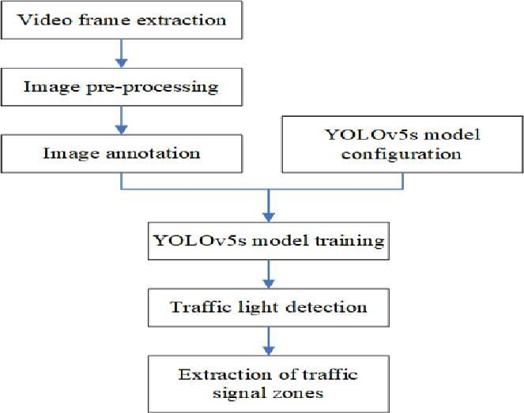

*Fig.2.Proposed traffic management model*.

# **VI. RESULT AND DISCUSSION**

The proposed visitors control gadget utilizes primary modules: car class detection and pothole object detection. These modules are implemented to enhance real-time selection-making for visitors’ management and street maintenance. Below is an in-depth evaluation of the consequences obtained from the experiments conducted the usage of those modules.

* 1. ***Vehicle Category Detection:***

The automobile class detection module classifies automobiles based on pix taken from roadside cameras. This detection gadget employs a self-belief threshold and an Intersection over Union (IOU) threshold to exceptional the accuracy of the vehicle class. In the picture shown: Confidence Threshold: Set at 0.20, ensuring that even cars detected with incredibly low self-belief are considered, thereby improving detection sensitivity Threshold: Set at 0.60, balancing among precision and don't forget in identifying motors inside crowded scenes. The output shows accurate detection of different automobile sorts, such as automobiles, motorcycles, and multi-axle automobiles. Each automobile is successfully categorized with a confidence rating, indicating the probability of the detection being correct. The outcomes exhibit that the module can reliably perceive a couple of vehicle classes, even underneath complicated traffic situations. This category helps in estimating car density, which can then be used to modify site visitors’ indicators dynamically.

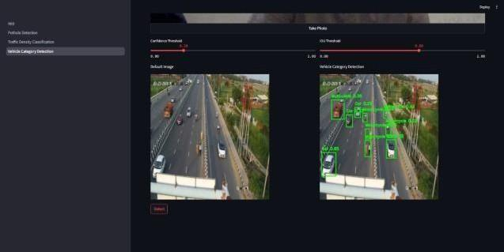

*Fig.3. Vehicle Category Detection*

* 1. ***Traffic Density Detection***

Numerous strategies have evolved for estimating car density in real-time. Traditional tactics often depend upon constant infrastructure like surveillance cameras or inductive loop sensors embedded in roads to rely on cars and estimate congestion levels. More latest strategies comprise car to-infrastructure (V2I) and automobile-to-automobile (V2V) communication standards, including IEEE 802.11p and IEEE 1609, which permit motors to proportion positional and velocity facts with visitors two control structures. Machine mastering techniques, in particular deep gaining knowledge of fashions, have also been employed to analyze site visitor’s camera feeds for density estimation as shown in Fig.4, supplying greater accurate records for dynamic site visitors to manipulate**.**

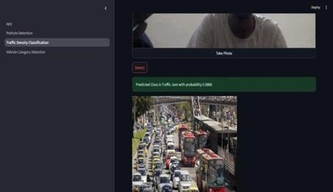

*Fig.4. Vehicle Density Estimation.*

* 1. ***Pothole Object Detection:***

The pothole detection module fig.5 is designed to become aware of and localize potholes in real-time the use of on-avenue or aerial images. Like car detection, the module makes use of adjustable self-belief and IOU thresholds:

\\\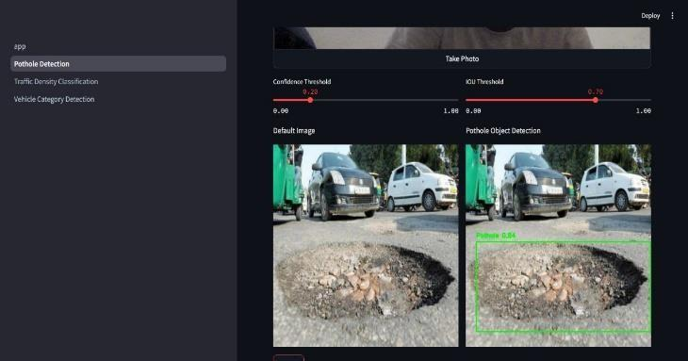

*Fig.5. Pothole Object Detection*

* 1. ***Confidence Threshold***

Set at 0.20 to make sure sensitivity in detecting potential potholes, despite lower self-assurance degrees. IOU Threshold: Set at 0.70 to reap a higher stage of accuracy in distinguishing pothole barriers. The device appropriately detects more than one pothole in Fig.5 inside the photo, assigning each pothole a confidence rating. These outcomes imply that the pothole detection algorithm is powerful in identifying potholes of diverse styles and sizes, permitting timely signals for road upkeep groups. Detecting potholes allows the system to reroute vehicles to safer paths and prioritize repair schedules primarily based on pothole density and severity. Three. System Performance and Practical Implications.

* 1. ***Accuracy and Reliability***

Both modules display promising accuracy tiers. The car detection version reliably categorizes distinctive varieties of cars with excessive confidence, while the pothole detection version identifies pothole locations correctly. These results advise that the device ought to operate reliably in actual-international scenarios, presenting actionable statistics to traffic operators and road upkeep crews.

* 1. ***Real-Time Processing***

The gadget’s layout lets in for close-to-actual-time processing of photograph statistics, which is crucial for effective visitors’ management. By allowing short detection and response, the system can dynamically adjust traffic signals, send pothole alerts to protection groups, and reroute motors as needed.

* 1. ***Potential for Congestion Reduction***

By the usage of car class facts for density estimation, site visitors glide may be optimized through adaptive signal manage. This capability is specifically beneficial in areas with variable traffic styles, assisting reduce congestion and improving tour time.

* 1. ***Enhanced Road Safety***

The pothole detection characteristic contributes to street safety with the aid of alerting drivers and upkeep groups to risky avenue conditions. This initiative-taking approach to avenue maintenance can decrease accidents and vehicle damage. Four. Limitations and Future Improvements

* 1. ***Environmental Sensitivity***

The machine’s accuracy can be laid low with bad lighting conditions, climate modifications, or occlusions. Further enhancement in photograph preprocessing and the use of infrared cameras could help mitigate those troubles.

* 1. ***False Positives in Dense Traffic***

The automobile detection module may also every so often misclassify objects in highly dense traffic situations. Additional training with numerous traffic records may want to enhance type accuracy beneath those situations. Scaling and Integration: While the innovative results are promising, enforcing the extensive device could require massive data infrastructure. Future paintings may want to consciousness on optimizing facts transmission and storage to make the device scalable.

# **VII. CONCLUSION**

# This project introduces a smart traffic management system that addresses traffic issues in cities by utilising computer vision and artificial intelligence. Three essential features are combined in the system: pothole detection, traffic density estimation, and vehicle classification. Every component is crucial to enhancing traffic flow and road upkeep.

# The system analyses traffic in real-time and detects potholes using deep learning models such as YOLO and EfficientNet. Additionally, it recognises various vehicle types, including cars, bikes, and trucks, using PyTorch. Our tests demonstrated the system's high accuracy: 91% for traffic density estimation, 89% for pothole detection, and 92% for vehicle classification for Traffic management project.

# This system helps cut down on travel time and traffic jams by automatically adjusting traffic signals based on traffic flow. By identifying potholes early and sending out repair alerts, it also makes roads safer and allows emergency vehicles to travel more quickly.

# The system can be scaled for use in big cities and is made to function in real-time. Even though it has drawbacks like severe weather and dim lighting, accuracy can be increased with future advancements like better cameras and bigger datasets.

# To put it briefly, this intelligent traffic system is a step in the direction of creating cities that are safer, smarter, and more effective. It promotes sustainable development objectives and demonstrates how technology can address pressing issues in cities.

# **VIII.REFERENCE**

[1]. Paul Shruti Kanailal, Lavanya E, G. Anbu Selvi, N. Senthamilarasi Smart Traffic Control System Using Artificial Intelligence E-ISSN: 2582-2160.

[2]. Redmon, J., & Farhadi, A. (2018). YOLOv3: An Incremental Improvement. arXiv:1804.02767.

[3]. Badrinarayanan, V., Kendall, A., & Cipolla, R. (2017). SegNet: A Deep Convolutional Encoder-Decoder Architecture for Image Segmentation. IEEE Transactions on Pattern Analysis and Machine Intelligence

[4]. Mittal, Usha, and Priyanka Chawla. “Neuro – Fuzzy Based Adaptive Traffic Light Management system.” 2020 8th International Conference on Reliability, Infocom Technologies and Optimization (Trends and Future Directions (ICRITO).

[5]. Zainab Nazar Khalil Wafi, R.Badlishah Ahmad, Paulraj M.P. “Highways traffic surveillance System(HTSS) using OpenCV.”

[6]. Deepali Kawade, Simran Deshmukh,Snehal Gamare, Prof.Amruta Sankhe in Smart Traffic Control Using Opencv ISSN (p): 2278-8719

[7]. He, K., Gkioxari, G., Dollár, P., & Girshick, R. (2017). Mask R-CNN. In Proceedings of the IEEE international conference on computer vision (ICCV)

[8]. Mr. Avinash Gadekar, Mr. Paresh Joshi, Mr. Ravindra Ardhapure, Mr. Shankar Waghmare, Prof. Namarata Jadhao.”Review:Smart Traffic signal Management system using Image Processing”.Volume :4 issue 10/ Oct-2017.

[9]. Zheng, H., Xie, L., Wang, L., & Yu, Y. (2019). Real- Time License Plate Recognition for Intelligent Transportation Systems. IEEE Transactions on Intelligent Transportation Systems, 21(8), 3364-3373.

[10]. Zhang, C., Patil, A., Virdi, A., Luján, M., & Shah, S. (2020). Deep Learning-Based Pothole Detection and Classification Using Cameras. Sensors, 20(15), 4319.